**Title: Advancing Assembly: AMT's High-Power Nutrunning Equipment**

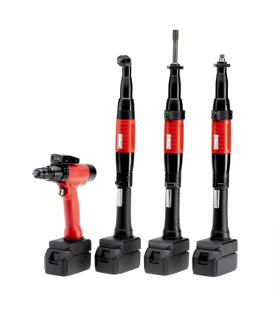

In the relentless world of automotive manufacturing, demands for ergonomic design, enhanced capability, and torque repeatability are ever-growing. [AMT's portable, rechargeable tools](https://absgroup.in/handheld-nutrunner), introduced in the Revision 08/2014, not only meet these demands but surpass them. This article unveils the innovative features that make these tools a game-changer in fastening operations.

**Ergonomics and Capability:**

The tools boast an appealing design with a focus on ergonomic factors:

- Ergonomically formed hand grip for heightened operator comfort.

- Bi-directional ring for clockwise/counterclockwise operation, featuring user-programmable switch functions for increased functionality.

- Status display with LEDs indicating rotation direction and additional functions like NOK acknowledgment and release.

- Electro-polished stainless steel START key for comfort and quality.

- 1-part, ergonomically formed angle head (rotatable 4 x 90°) for durability and dependability.

**Increased Power and Efficiency:**

Utilizing a new-generation, high-dynamic motor, AMT achieves a remarkable 30% increase in nutrunner power. The outcome is faster, more cost-efficient fastening operations, contributing to heightened productivity.

**Robust Design for Industrial Rigors:**

Built for rugged industrial applications, the tools feature:

- Polyamide hand grip with a high fiberglass content.

- Motor cover made from high-strength polyurethane.

- Gearbox configured for long-life operation.

This robust design leads to an extended tool lifetime, minimizing maintenance costs and ensuring reliable performance in challenging environments.

**Smart Integration:**

- *Integrated Data Chip:* Stores relevant spindle data, automatically readable on any [AMT control](https://absgroup.in/fixture-spindle), eliminating tedious parameter definitions.

- *Reaction Torque Sensors:* Ensure precise and consistent fastening processes, meeting high-quality standards.

- *Integrated Barcode Reader:* Scans part IDs, retrieves the correct fastening program, and stores data in a quality database, reducing cycle time and assembly costs.

- *Wireless Data Transfer:* Ensures safe and reliable communication between the tool and control via a WLAN module, enhancing data transfer efficiency.

**Conclusion:**

[AMT's High-Power Nutrunning Equipment](https://absgroup.in/battery-powered-tools) redefines assembly processes, marrying cutting-edge technology with ergonomic design. From increased power to smart integration features, these tools are poised to elevate your manufacturing operations to new heights, ensuring precision, efficiency, and cost-effectiveness.